Answer ALL the questions. (Topic: Nested Loop & Problem solving)

1. Based on the following code segment, predict the output.

|  |  |  |  |
| --- | --- | --- | --- |
| (a) | int p, q;  for(p=1;p<6;p++)  {  for(q=p;q>0;q--)  {  printf("%d ",q);  }  printf("\n");  } | (b) | int i,j,k;  for(i=1;i<=5;i++)  {  for(j=1;j<=3;j++)  {  for(k=1;k<=4;k++)  printf("C");  printf("\n");  }  printf("\n"); } |
| (c) | int r,c,ht=3,w=5;  for(r=1;r<=ht;r++)  {  for(c=1;c<=w;c++)  {  if((r%2==0)&&(c%2==0))  printf("X");  else  printf("*");  }  printf("\n");  } | (d) | int a=1, b;  do  {  b=1;  do  {  printf("%d ",a*b);  b++;  }while(b<6);  a++;  }while(a<3); |

1. Write a C code that prints the following patterns.

|  |  |  |  |  |  |
| --- | --- | --- | --- | --- | --- |
| (a) | **********  *********  ********  *******  ******  *****  ****  ***  **  * | (b) | *  **  ***  ****  *****  ******  *******  ********  *********  ********** | (c) | **********  *********  ********  *******  ******  *****  ****  ***  **  * |

1. Write a program that reads an integer from 1 to 9 representing the rows in order to create the following pattern (form of a right triangle).

Enter a number between 1 and 9: 6

1

12

123

1234

12345

123456

1. Write a complete C code that cause the following output to be displayed:

0  
0 1  
0 1 2  
0 1 2 3  
0 1 2 3 4  
0 1 2 3 4 5  
0 1 2 3 4  
0 1 2 3  
0 1 2  
0 1  
0

1. Write a complete C code that cause the following output to be displayed:

0 1 0 1 0 1  
1 0 1 0 1 0

0 1 0 1 0 1  
1 0 1 0 1 0

0 1 0 1 0 1  
1 0 1 0 1 0

1. Write a program that finds the average number of hours per day that a given student studies programming as well as chemistry. For each given student include two prompts, one for each subject. Have the program print out which subject the student, on average, spent the most time on.

This program will find the average number of hours a day

each given student spent on programming and on chemistry over a long weekend

How many students are there? 3

Enter the number of days in the long weekend: 2

Enter student 1 day 1 programming hrs: 3

Enter student 1 day 1 chemistry hrs: 2

Enter student 1 day 2 programming hrs: 2

Enter student 1 day 2 chemistry hrs: 1

The average number of hours per day spent programming by student 1 is 2.5

The average number of hours per day spent chemistry by student 1 is 1.5

This student averaged more time on programming.

Enter student 2 day 1 programming hrs: 1

Enter student 2 day 1 chemistry hrs: 2

Enter student 2 day 2 programming hrs: 1

Enter student 2 day 2 chemistry hrs: 3

The average number of hours per day spent programming by student 2 is 1.0

The average number of hours per day spent chemistry by student 2 is 2.5

This student averaged more time on chemistry.

Enter student 3 day 1 programming hrs: 1

Enter student 3 day 1 chemistry hrs: 1

Enter student 3 day 2 programming hrs: 1

Enter student 3 day 2 chemistry hrs: 1

The average number of hours per day spent programming by student 3 is 1.0

The average number of hours per day spent chemistry by student 3 is 1.0

This student spent the same amount of time on both subjects.

Note that the inner loop of this program is executed n times—once for each day of the long weekend. Here, n is a positive integer input by the user. In other words, the user decides how many days to consider just as they choose how many students to consider.

1. The Infinite Series for Inverse of Tangent and Inverse of Hyperbolic Tangent functions of a variable U are given respectively by the series expansion below.

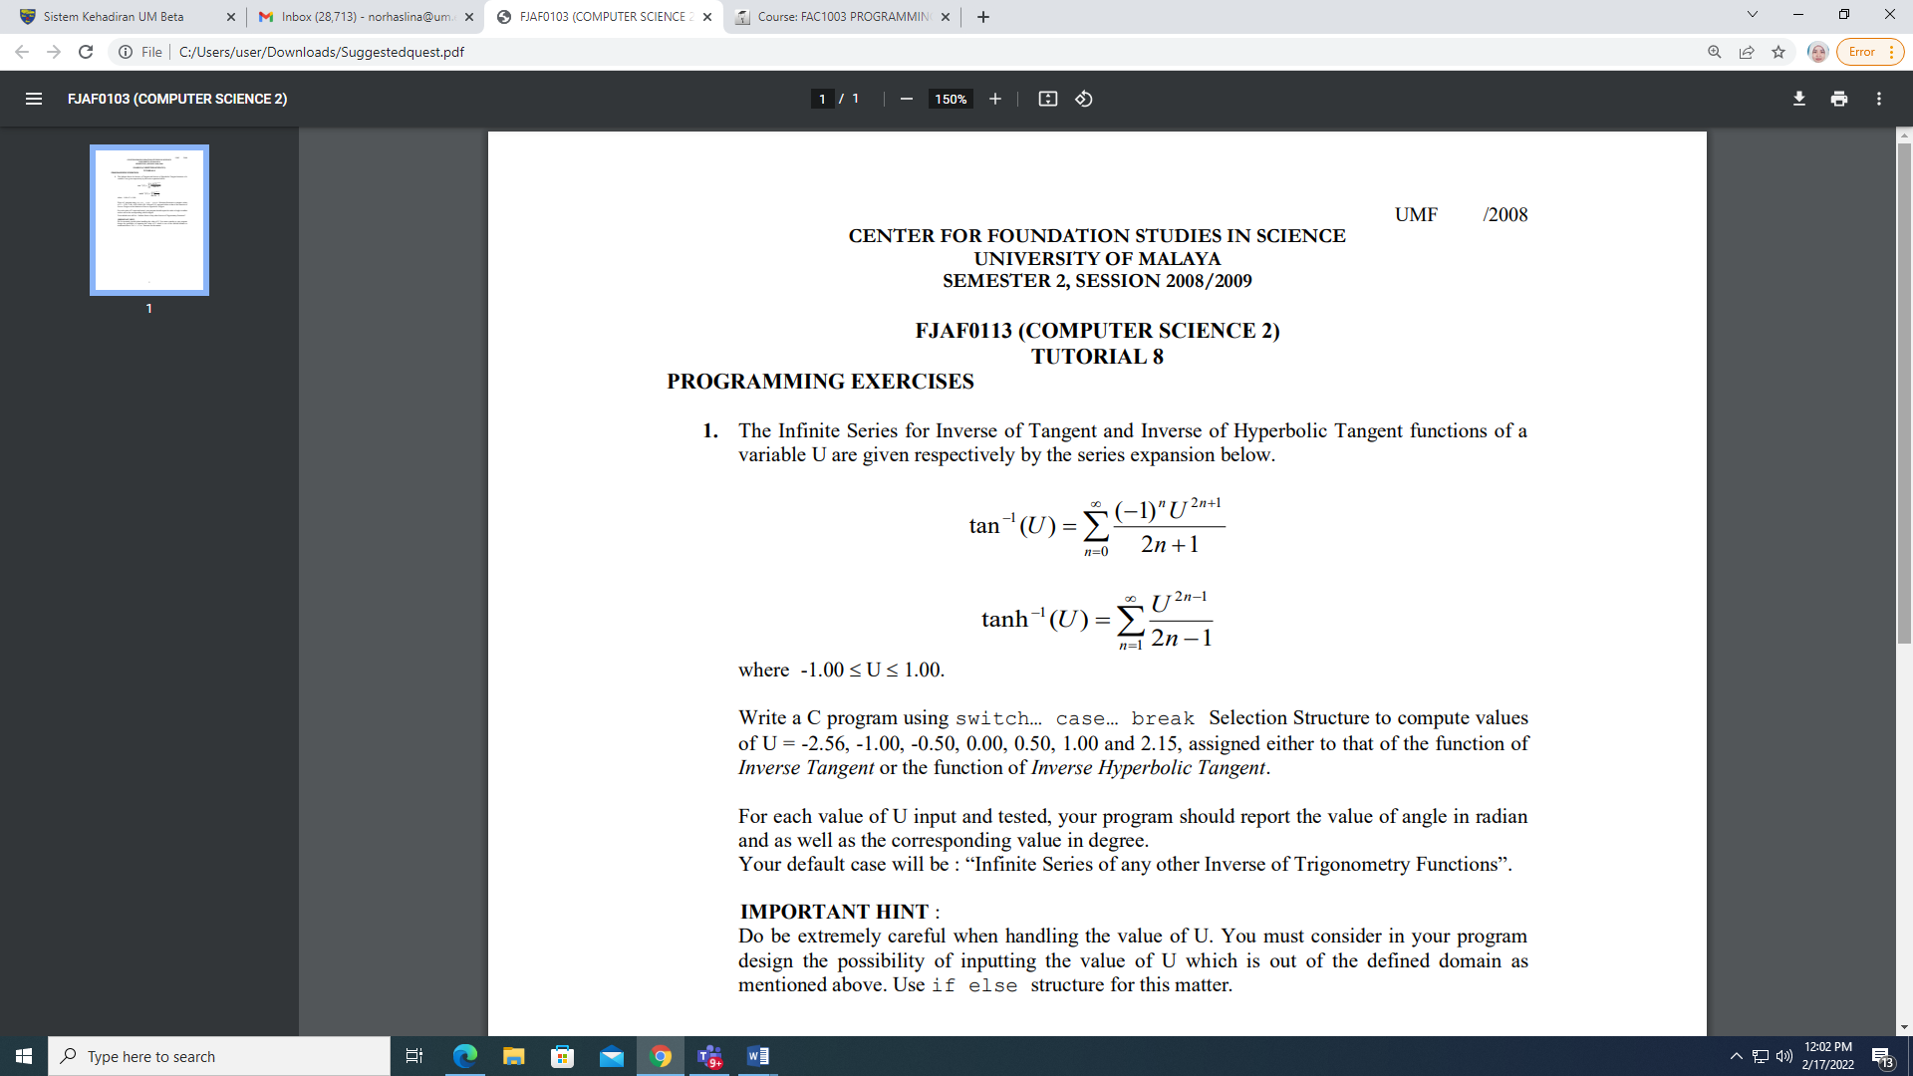

Write a C program using Selection Control Structure to give an option for the user to choose between the function given and compute the output by using the Repetition Control Structure.

For each value of U input and tested, your program should report the value of angle in radian and as well as the corresponding value in degree.

IMPORTANT HINT:

Do be extremely careful when handling the value of U. You must consider in your program design the possibility of inputting the value of U which is out of the defined domain as mentioned above.

1. Write a program that can check whether the given passwords match or not. The password is in the form of a string. The program can be repeated if the user wants it. (Please use sentinel value for it).

The valid password is “pasum21” and “pasum22”

Tip: The comparison data string must use #include<string.h> for the library file and use the

function strcmp(variable, "value")==0 in the conditions section.

Enter your password

pasum21

Your password VALID

-----------------------------

Do you want to check again (Enter Y/y): Y

Enter your password

pasum

WRONG password

-------------------------

Do you want to check again (Enter Y/y): y

Enter your password

pasum22

Your password VALID

-----------------------------

Do you want to check again (Enter Y/y): n

END PROGRAM

Thank You!

Example output: